## [**He's back! Christopher Meloni films scenes for his old show Law & Order: Special Victims Unit with Mariska Hargitay... a month after crew member was killed on the set of his spinoff Law & Order: Organized Crime**](https://www.dailymail.co.uk/tvshowbiz/article-11120895/Christopher-Meloni-films-scenes-old-Law-Order-Special-Victims-Unit-Mariska-Hargitay.html)

By [SAM JOSEPH SEMON FOR DAILYMAIL.COM](https://www.dailymail.co.uk/home/search.html?s=&authornamef=Sam+Joseph+Semon+For+Dailymail.com)

**PUBLISHED:** 19:46 BST, 17 August 2022 | **UPDATED:** 19:56 BST, 17 August 2022

* [e-mail](mailto:?subject=Read%20this:%20He%27s%20back!%20Christopher%20Meloni%20films%20scenes%20for%20his%20old%20show%20Law%20&%20Order:%20Special%20Victims%20Unit%20with%20Mariska%20Hargitay...%20a%20month%20after%20crew%20member%20was%20killed%20on%20the%20set%20of%20his%20spinoff%20Law%20&%20Order:%20Organized%20Crime&body=He%27s%20back%21%20Christopher%20Meloni%20films%20scenes%20for%20his%20old%20show%20Law%20%26amp%3B%20Order%3A%20Special%20Victims%20Unit%20with%20Mariska%20Hargitay...%20a%20month%20after%20crew%20member%20was%20killed%20on%20the%20set%20of%20his%20spinoff%20Law%20%26amp%3B%20Order%3A%20Organized%20Crime%0A%0AChristopher%20Meloni%20was%20spotted%20while%20working%20on%20the%20New%20York%20City%20set%20of%20Law%20%26amp%3B%20Order%3A%20Special%20Victims%20Unit%20on%20Tuesday%20afternoon.%20The%2061-year-old%20actor%20was%20joined%20by%20his%20Mariska%20Hargitay.%0A%0Ahttps%3A%2F%2Fwww.dailymail.co.uk%2Ftvshowbiz%2Farticle-11120895%2FChristopher-Meloni-films-scenes-old-Law-Order-Special-Victims-Unit-Mariska-Hargitay.html%3Fito%3Demail_share_article-top%0A%0A%0AMost%20Read%20Articles%3A%0A%0A%27A%20lot%20of%20people%20think%20I%27m%20on%20drugs%27%3A%20Lewis%20Capaldi%20leaves%20viewers%20in%20stitches%20as%20he%20jokingly%20offers%20Lorraine%20Kelly%20%27seven%20inches%20of%20me%27%20while%20discussing%20his%20Tourette%27s%20diagnosis%0Ahttps%3A%2F%2Fwww.dailymail.co.uk%2Ftvshowbiz%2Farticle-11205879%2FLewis-Capaldi-jokingly-offers-Lorraine-Kelly-seven-inches-discusses-Tourettes-diagnosis.html%3Fito%3Demail_share_article-top_most-read-articles%0A%0AStrictly%20Come%20Dancing%27s%20launch%20is%20postponed%3A%20Bosses%20confirm%20series%20opener%20will%20air%20on%20September%2023%20following%20the%20Queen%27s%20death%0Ahttps%3A%2F%2Fwww.dailymail.co.uk%2Ftvshowbiz%2Farticle-11206407%2FStrictly-Come-Dancings-launch-postponed.html%3Fito%3Demail_share_article-top_most-read-articles%0A%0A%27She%20forgets%20she%20started%20this%27%3A%20Backlash%20over%20Oprah%20Winfrey%27s%20%27cheek%27%20for%20saying%20she%20hopes%20Queen%27s%20death%20will%20help%20Harry%20and%20Meghan%20make%20%27peace%27%20with%20The%20Firm%20-%20after%20HER%20interview%20with%20Sussexes%20sent%20shockwaves%20through%20the%20monarchy%C2%A0%0Ahttps%3A%2F%2Fwww.dailymail.co.uk%2Fnews%2Farticle-11205717%2FOprah-Winfrey-criticised-saying-hopes-Harry-Meghan-make-peace-Royal-Family.html%3Fito%3Demail_share_article-top_most-read-articles%0A%0A)

**2.6k**shares

[**50**](https://www.dailymail.co.uk/tvshowbiz/article-11120895/Christopher-Meloni-films-scenes-old-Law-Order-Special-Victims-Unit-Mariska-Hargitay.html#comments)

[View comments](https://www.dailymail.co.uk/tvshowbiz/article-11120895/Christopher-Meloni-films-scenes-old-Law-Order-Special-Victims-Unit-Mariska-Hargitay.html#comments)

* [e-mail](mailto:?subject=Read%20this%3A%20He%27s%20back!%20Christopher%20Meloni%20films%20scenes%20for%20his%20old%20show%20Law%20%26%20Order%3A%20Special%20Victims%20Unit%20with%20Mariska%20Hargitay...%20a%20month%20after%20crew%20member%20was%20killed%20on%20the%20set%20of%20his%20spinoff%20Law%20%26%20Order%3A%20Organized%20Crime&body=He%27s%20back!%20Christopher%20Meloni%20films%20scenes%20for%20his%20old%20show%20Law%20%26%20Order%3A%20Special%20Victims%20Unit%20with%20Mariska%20Hargitay...%20a%20month%20after%20crew%20member%20was%20killed%20on%20the%20set%20of%20his%20spinoff%20Law%20%26%20Order%3A%20Organized%20Crime%0A%0AChristopher%20Meloni%20was%20spotted%20while%20working%20on%20the%20New%20York%20City%20set%20of%20Law%20%26%20Order%3A%20Special%20Victims%20Unit%20on%20Tuesday%20afternoon.%20The%2061-year-old%20actor%20was%20joined%20by%20his%20Mariska%20Hargitay.%0A%0Ahttps%3A%2F%2Fwww.dailymail.co.uk%2Ftvshowbiz%2Farticle-11120895%2FChristopher-Meloni-films-scenes-old-Law-Order-Special-Victims-Unit-Mariska-Hargitay.html%3Fito%3Demail_share_article-floatingBar)

[Top](https://www.dailymail.co.uk/tvshowbiz/article-11120895/Christopher-Meloni-films-scenes-old-Law-Order-Special-Victims-Unit-Mariska-Hargitay.html#top)

[+99](https://www.dailymail.co.uk/)

[Home](https://www.dailymail.co.uk/)

[**50**](https://www.dailymail.co.uk/tvshowbiz/article-11120895/Christopher-Meloni-films-scenes-old-Law-Order-Special-Victims-Unit-Mariska-Hargitay.html#comments)

[View comments](https://www.dailymail.co.uk/tvshowbiz/article-11120895/Christopher-Meloni-films-scenes-old-Law-Order-Special-Victims-Unit-Mariska-Hargitay.html#comments)

Christopher Meloni has his own Law & Order show called Organized [**Crime**](https://www.dailymail.co.uk/news/crime/index.html) which he has been filming this year.

But on Tuesday the actor, 61, was seen guest starring on his old TV show Law & Order: Special Victims Unit with Mariska Hargitay. The actor seems to be filming a cross over episode.

The long-running police procedural program SVU is currently working on its forthcoming 24th season, which will premiere in September.



**+10**

View gallery

**Doing his thing: Christopher Meloni was spotted with Mariska Hargitay while working on the New York City set of Law & Order: Special Victims Unit on Tuesday afternoon**

**Christopher Meloni joins Mariska Hargitay on Law & Order: SVU**

Loaded: 0%

Progress: 0%

0:00

Previous

Play

Skip

Mute

Current Time0:00

/

Duration Time0:26

Fullscreen

Need Text

There will reportedly be a lot of Law & Order crossing over this fall, according to TV LINE, as the original Law & Order, Hargitay's SVU and Meloni's Organized Crime will be airing back to back on the same night.

ADVERTISEMENT

Law & Order Season 22, Law & Order: SVU Season 24 and Law & Order: Organized Crime Season 3 will all premiere September 22.

Meloni has not been pictured filming a guest starring role on SVU in over a year. He wore a long-sleeve t-shirt and a set of slim-fitting navy blue trousers as he filmed his scenes.

## **RELATED ARTICLES**

* [Previous](https://www.dailymail.co.uk/tvshowbiz/article-11120895/Christopher-Meloni-films-scenes-old-Law-Order-Special-Victims-Unit-Mariska-Hargitay.html#)
* [1](https://www.dailymail.co.uk/tvshowbiz/article-11120895/Christopher-Meloni-films-scenes-old-Law-Order-Special-Victims-Unit-Mariska-Hargitay.html#)
* [Next](https://www.dailymail.co.uk/tvshowbiz/article-11120895/Christopher-Meloni-films-scenes-old-Law-Order-Special-Victims-Unit-Mariska-Hargitay.html#)
* [**Christopher Meloni spotted on the New York City set of Law &...**](https://www.dailymail.co.uk/tvshowbiz/article-11033705/Christopher-Meloni-spotted-New-York-City-set-Law-Order-Organized-Crime.html)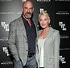[**Law & Order star Christopher Meloni, 60, makes very rare...**](https://www.dailymail.co.uk/tvshowbiz/article-10072979/Law-Order-star-Christopher-Meloni-60-makes-rare-appearance-wife-26-years.html)

## **SHARE THIS ARTICLE**

Share

Hargitay, 58, opted for an all-black outfit that included a wide-necked shirt and a matching pair of pants.

The actress also accessorized with a set of tinted sunglasses and several pieces of jewelry.

The performer's hair fell onto her shoulders and gave an element of color to her otherwise monotone outfit.



**+10**

View gallery

**In costume: Meloni wore a long-sleeve t-shirt and a set of slim-fitting navy blue trousers as he filmed his scenes**

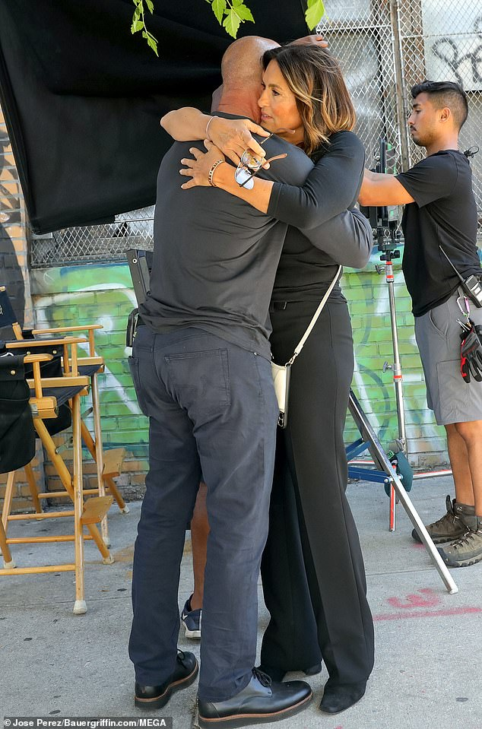

**+10**

View gallery

**Getting close: The 61-year-old actor was joined by his former costar Hargitay, and the pair shared a hug during their time in the program's production area**

Meloni began portraying Detective Elliot Stabler during Law & Order: Special Victims' first season, which premiered in 1999.

The performer starred alongside Hargitay, who plays Captain Olivia Benson and has remained with the program for its entire length on the air.

The actor stayed with the fan-favorite show for a total of twelve seasons, and he was nominated for the Primetime Emmy Award for Outstanding Lead Actor in a Drama Series in 2006.

He announced that he would be leaving the program in 2013, with unsuccessful salary negotiations being cited as the reason for his departure.

**Christopher Meloni films 'Law & Order: Organized Crime' in NYC**

Loaded: 0%

Progress: 0%

0:00

Previous

Play

Skip

Mute

Current Time0:00

/

Duration Time0:22

Fullscreen

Need Text



**+10**

View gallery

**Longtime cast member: Meloni began portraying Detective Elliot Stabler during Law & Order: Special Victims' first season, which premiered in 1999**



**+10**

View gallery

**Taking his leave: He announced that he would be leaving the program in 2013, with unsuccessful salary negotiations being cited as the reason for his departure**

Stabler was subsequently written off the program and given an off-screen exit.

Meloni went on to make a guest appearance on the show during an episode entitled Return of the Prodigal Sun, which premiered last April.

The actor's return to the program was well-received by fans, and his performance was praised by many critics. And it looks like he will be back on SVU this fall.

The performer has since reprised his role as Stabler in Law & Order: Organized Crime, which premiered last year.

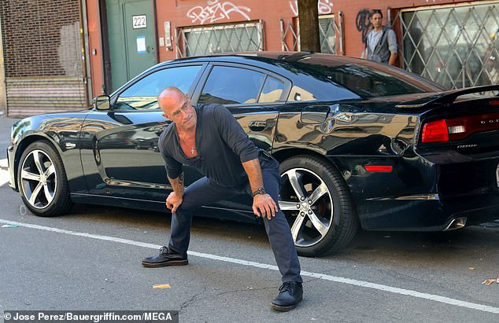

**+10**

View gallery

**Back at it: The performer has since reprised his role as Stabler in Law & Order: Organized Crime, which premiered last year**

Meloni spoke about working on the program during an interview with [**Men's Health**](https://www.menshealth.com/fitness/a37081725/christopher-meloni-interview-law-and-order-organized-crime/) and expressed that he was happy to be able to return to the Law & Order franchise on his terms.

'It felt good to have to make that decision—which was a big yes-or-no decision—with a sense of clarity and a sense of certain things being correct,' he said.

The performer made a point of adding: 'This time around with the Law & Order ride, I'm not stressed.'

**The original Law & Order is back on NBC in this exciting promo**

Loaded: 0%

Progress: 0%

0:00

Previous

Play

Skip

Mute

Current Time0:00

/

Duration Time2:58

Fullscreen

Need Text

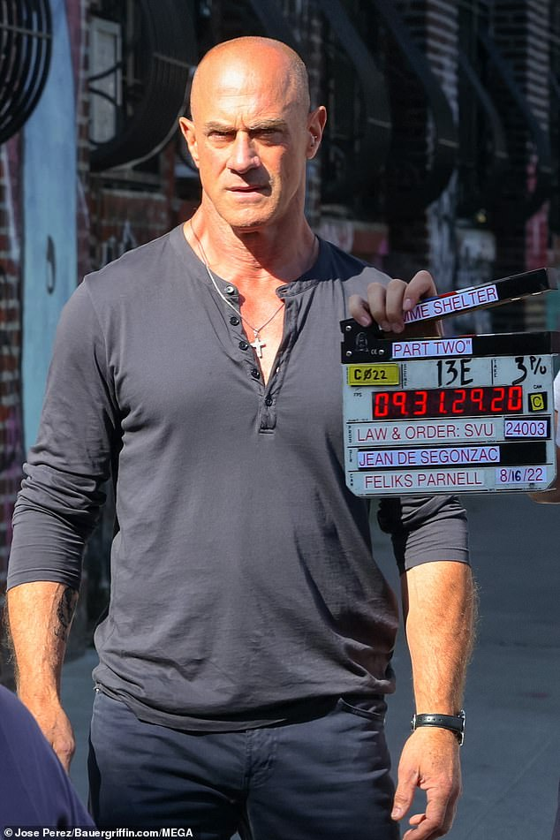

**+10**

View gallery

**Doing well: Meloni spoke about working on the program during an interview with Men's Health and expressed that he was happy to be able to return to the Law & Order franchise on his terms**

In July crew member Johnny Pizzaro was fatally shot on the set of Meloni's spinoff show Law & Order: Organized Crime.

The New York Police Department identified Johnny Pizarro, 31, as the victim of an apparent execution-style killing on the set of Law & Order: Organized Crime.

Pizarro was in charge of parking enforcement on the set, with the murder taking place around 5:15 AM on Wednesday.

The crew member was in his vehicle in Greenpoint when someone opened his door and shot the victim in his face and neck.

**Read more:**

* [**Christopher Meloni on Law & Order: Organized Crime, Working Out, and Being a Zaddy**](https://www.menshealth.com/fitness/a37081725/christopher-meloni-interview-law-and-order-organized-crime/)

### **Share or comment on this article:**

# Christopher Meloni films scenes for old show Law & Order: Special Victims Unit with Mariska Hargitay